**Test Result Report Team #3**

**for**

[**TravelWorse**](https://travelbetter.app)

**Version 5.0**

**22/09/2021-24/09/2021**

**Table of contents:**

1. **Introduction**
2. **Testing process description**
3. **Summary**
4. **Testing time**
5. **Test status**
6. **Recommendations and conclusions**
7. **Introduction**

The purpose of this document is to report on the work done on the TravelWorse application, which is being tested by the Team#3 as part of a training project.

The Travelworse application is a planner of upcoming trips. The team finished working on the requirements and started working on the preparation of test documentation. The team has established a communication process, the roles in the project are distributed. In order to quickly answer any questions that arise or share an idea with colleagues, a chat was created in the messenger, where the main communication of the team takes place.

1. **Testing process description**

The requirements were tested by the team. The questions were compiled for the product owner, and the answers were received. Based on the responses, the team members made changes to the requirements. The requirements have been formed. The team started writing test documentation.

When testing a project, the team adheres to the test plan - The [Test plan Team#3](https://docs.google.com/document/d/1jFq5OmjdqfJryo0dSRAnOkeyGLdV72ZOxN2FQ1pMLFU/edit)

1. **Summary**

Test status: **GREEN**

The team tested the requirements presented in the form of a user story. The team members formed a list of questions about the requirements, in addition, the team ranked their questions by the degree of importance. The requirements were submitted to the product owner for consideration. The team received answers to the questions and made changes to the user history. At this stage, the team started compiling checklists in order to prepare for writing test cases in the TestRail application

There was an attempt to contact the developers of the application. At the moment, there was no response to the letter.

The team continues to improve the skills of working in the Jira application.

The team was familiarized with the test plan for the project.

1. **Testing time**

| **Full name** | **Date** | **Description** | **Duration, h** |
| --- | --- | --- | --- |
| Ilya Dyuzhev | 22.09.2021 | Working on the strategy | 2 |
| Ekaterina Drabskaya | 23.09.2021 | Writing test documentation | 2,5 |
| Ilona Victorchyk | 23.09.2021 | Writing test documentation | 3 |
| Irina Milushkina | 23.09.2021 | Writing test documentation | 3 |
| Irina Milushkina | 24.09.2021 | Writing test documentation | 4 |
| Ekaterina Drabskaya | 24.09.2021 | Writing test documentation | 4 |
| Ilona Victorchyk | 24.09.2021 | Writing test documentation | 4 |

1. **Test status**
2. Requirements

Due to the lack of customer requirements, user stories were created that the team worked with. The formation of clear requirements for the application was based on the questions of team members that arose when reading the user's history

The requirements were formed and transferred to the “Jira " applications. After that, the team received answers to questions about the requirements and supplemented the acceptance criteria in the user history

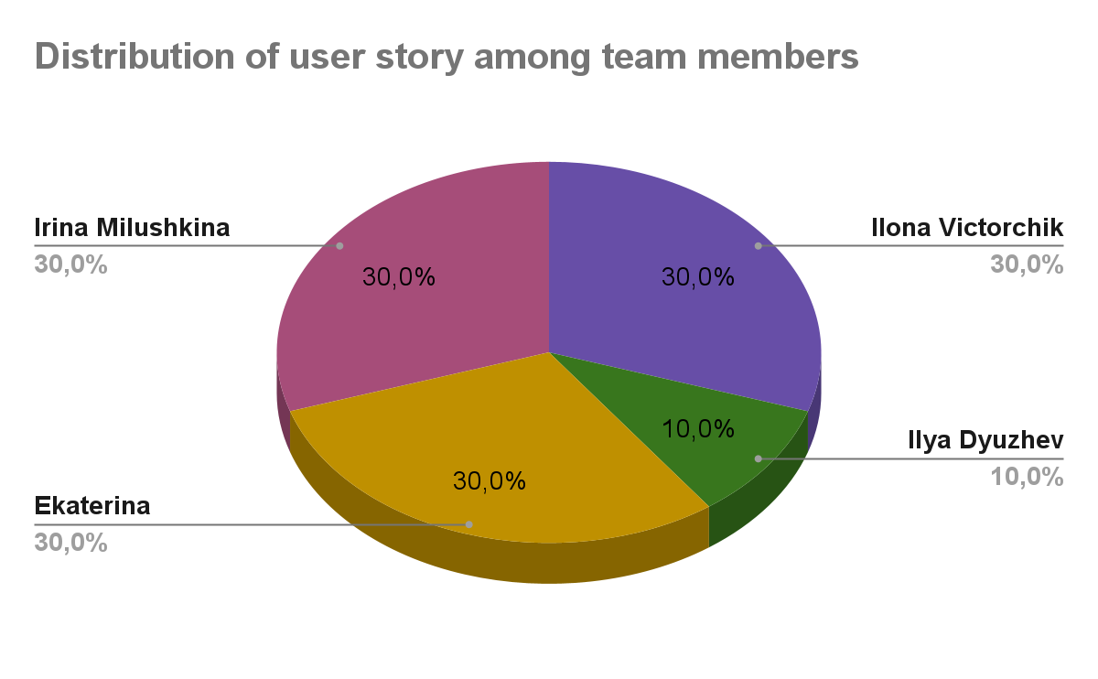

Based on the" user story", 141 questions were created by

the team members.

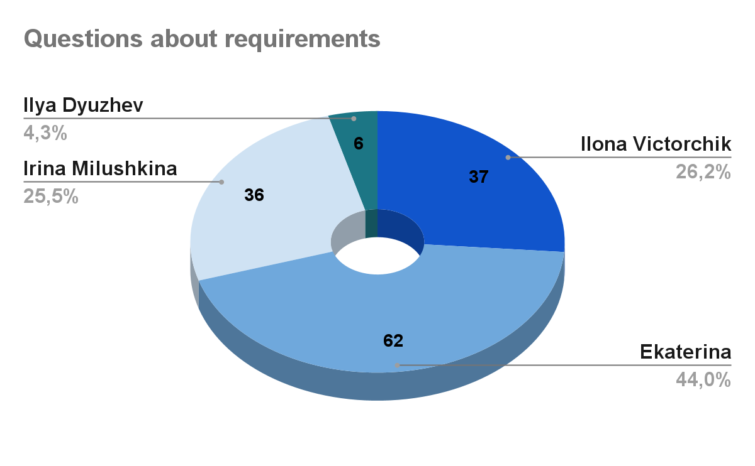

The team received answers to the questions, some of them were rejected:

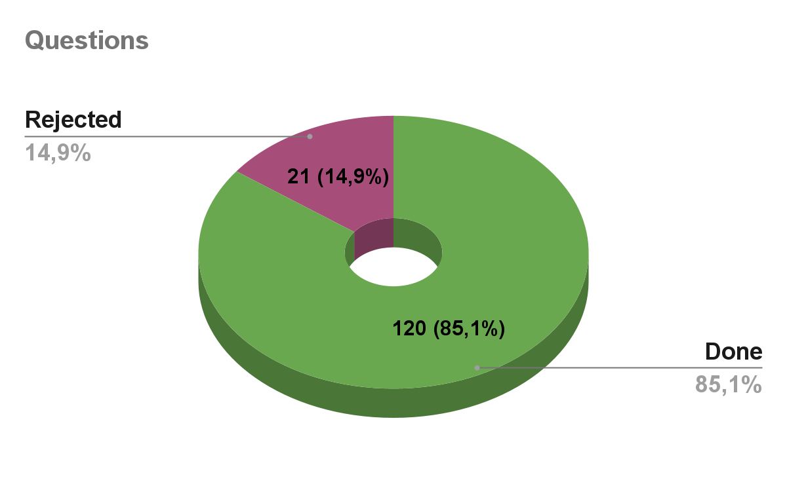

1. **Recommendations and conclusions**

The requirements presented in the form of a user story were tested and finalized based on the answers to questions about the requirements. The team started writing test documentation, starting with checklists. Due to time constraints, the team needs to actively finish working on checklists and start writing test cases. You need to consolidate your skills in Jira and refresh your memory of working skills in the TestRail application